**Quality of life of pediatric brain tumour patients : Prediction by incorporation of Ensemble approach into Automated machine learning**

**Ali Haider Shah1, Dr Tauseef Ullah2, Dr Iftikhar Bazai3, Professor Dr Inayat Ullah Khan4, Arshiya Fatima1, Saiqa Zehra1, Syed Mohammad Mehmood Abbas1, Adil Baloch1, Ali Danish Khan Yousfzai1, Ayesha Khalid Khan1, Hashir Fahim Khawaja1, Shafqat Rasool1, Ali Haider Bangash1**

1STMU Shifa College of Medicine, Islamabad, Pakistan

2Post-graduate trainee, Department of Neurosurgery, Hayatabad Medical Complex, Peshawar, Pakistan

3Post-graduate trainee, Department of Neurosurgery, Bolan Medical Complex, Quetta, Pakistan

4Chief of Neurosurgery, Kulsum International Hospital, Islamabad, Pakistan

**Background:** Cognitive parameters such as those outlined as cardinal components of the Wechsler Intelligence Scale for Children are adopted to assess the quality of life of children who have suffered from brain tumors. With Artificial intelligence in general and machine learning in particular exhibiting superior predictive and prognositicative capabilities, when compared with conventional statistical techniques, for neurological as well as non-neurological conditions, we explored automated Machine Learning to predict those cognitive parameters including but not limited to Full Scale Intelligent Quotient and Working Memory Index in the said patient population with the aim to optimize the relevant rehabilitation protocols.

**Methodology:** The study population comprised 73 children— who suffered from brain tumours during their developmental age— assessed at the Scientific Institute for Research, Hospitalization and Healthcare (IRCCS), Eugenio Medea Scientific Institute.[1]

The current state of the art (SOTA) for automated Machine Learning (aML)[2] was adopted to develop predictive models using algorithms including Neural Network, eXtreme Gradient Boosting and CatBoost with employment of hyperparameter tuning.

Ensemble approach, which is the amalgamation of two or more than two algorithmic models to develop such a model which is better than either of its computive components, was superimposed. Root means square error (RSME) assessed the predictive ability of the developed models.

**Results:** An ensemble of Xgboost and Random Forest (RF) with superimposed Boost on Errors predicted Verbal Comprehension Index with an RMSE of 16.3. An ensemble of Xgboost and CatBoost predicted Visual Spatial Index with an RMSE of 17.8.

An ensemble of Decision Tree (DT), RF and Neural Network (NN) predicted Full Scale Intelligent Quotient with an RMSE of 15.1. Age at assessment was recognized as the most influential predictor. **(Figure 1)** An ensemble of Xgboost, NN, CatBoost and RF predicted Working Memory Index with an RMSE of 17.8 with tumor type recognized as the most influential predictor. **(Figure 2)**

An ensemble of Light Gradiant Boosting Machine, CatBoost and Extra Trees predicted Processing Speed Index with an RMSE of 16.4 with tumor type, age at diagnosis and institution of radiotherapy recognized as the most influential predictors. **(Figure 3)**

**Conclusions:** Our novel approach to develop cognitive function predictive models for pediatric brain tumour patients by exploring automated machine learning is the very first attempt of its nature. Adoption of the current SOTA for aML provides optimal predictions which, when incorporated into the respective prognosticative and rehabilitation protocols, shall translate into a decrease in the morbidity associated with pediatric brain tumours by assisting in risk stratification and complication triaging.

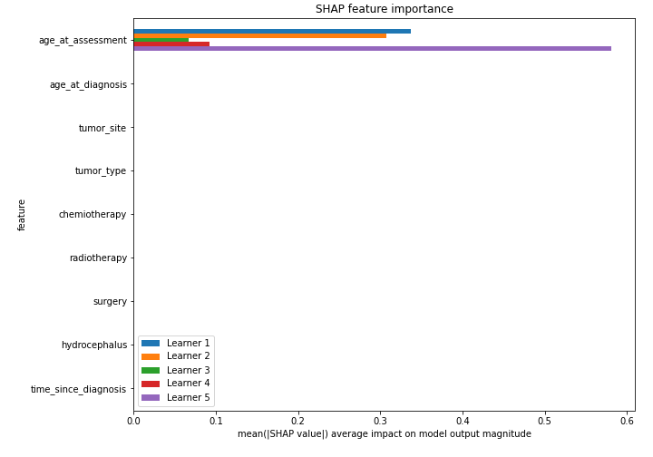

**Figure 1.** Relative influence of predictors for Full Scale Intelligent Quotient in pediatric brain tumour patients

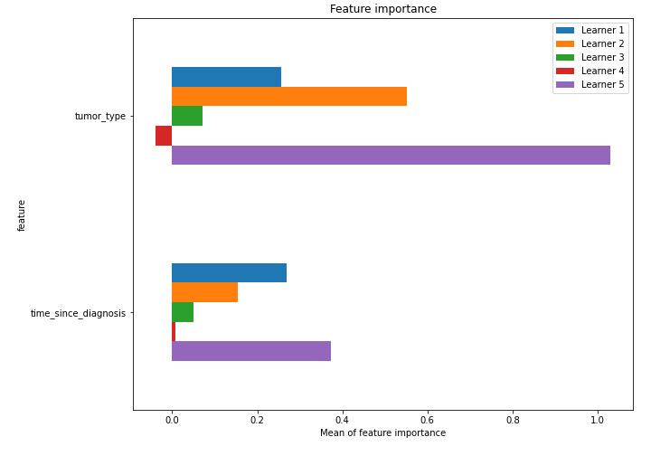

**Figure 2.** Relative influence of predictors for Working Memory Index in pediatric brain tumour patients

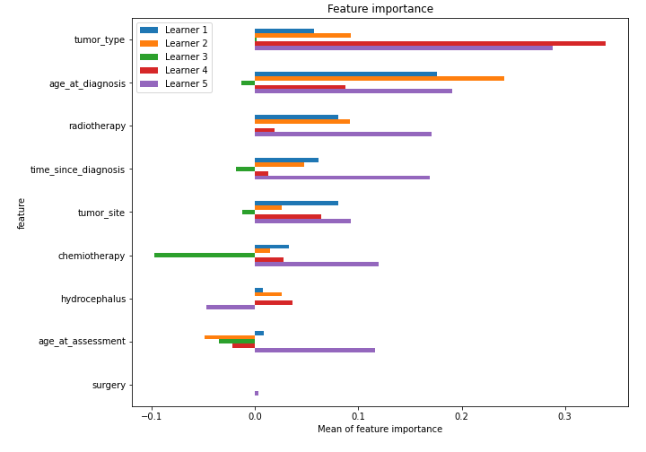

**Figure 3.** Relative influence of predictors for Processing Speed Index in pediatric brain tumour patients

1. Oprandi Maria Chiara. (2021). Cognitive and clinical predictors of adaptive functioning in pediatric brain tumor survivors. (Version 001) [Data set]. Zenodo. https://doi.org/10.5281/zenodo.4733570
2. AutoML Compare. MLJAR Automated Machine Learning. https://mljar.com/automl-compare/. Published 2021. Accessed February 15, 2022.